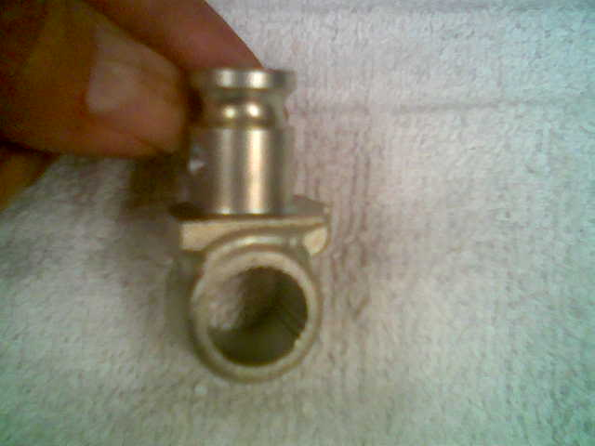

This is the boss for a ’99 KX250

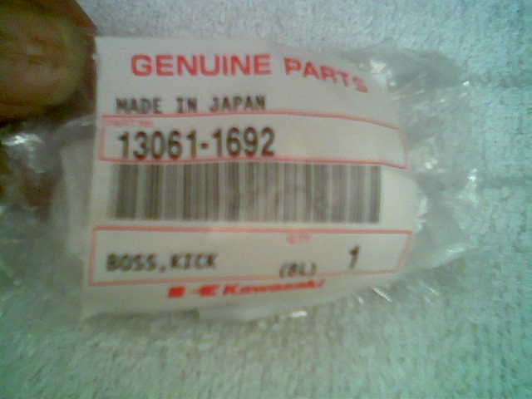

This is the packaging it came in

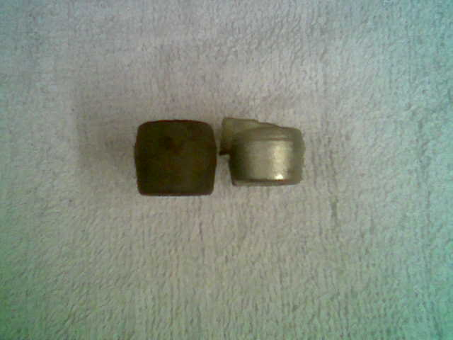

This is the KX boss next to a KDX boss. Note that it is narrower. I had to use a thick washer to make up that difference. We’ll see how well that works over time; I think it will be fine.

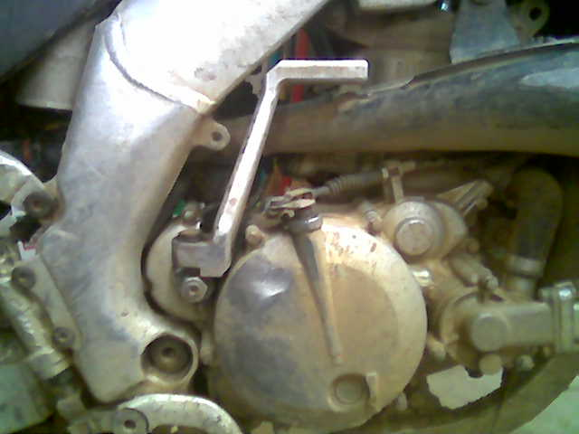

This is the FRP lever mounted. This is in a CR250 frame. Where the “heel” of that lever is filed flat it used to fit right up against the frame. The pivot between the KDX boss and the FRP lever is wallowing out pretty fast

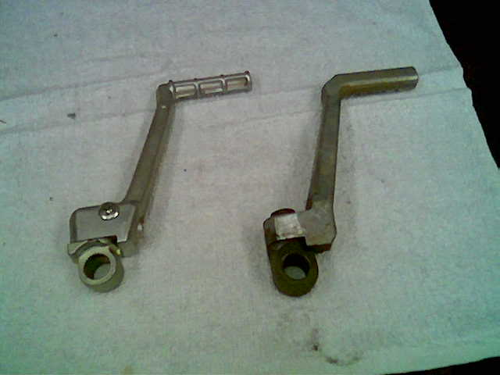

This is the two levers. The one on the right is a ’99 KX250 boss with a ’95 KX125 lever. I had to file a little bit on the groove that the Phillips head screw engages on the boss, other than that the two parts fit together properly.

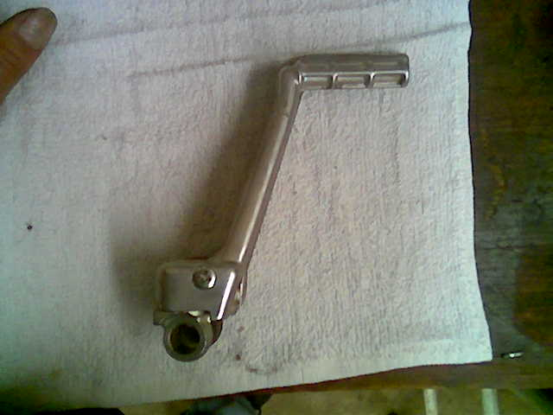

This is the two levers stacked on top of each other. They are almost exactly the same shape.
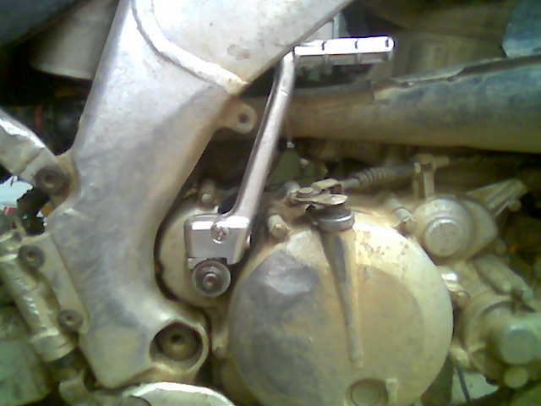

This is the new lever mounted on the bike. Note how much I had to file off the “heel” of this lever to clear the frame. I’m pretty sure the KDX frame does not have this clearance problem. I hope this does not weaken the lever too much. Time will tell.

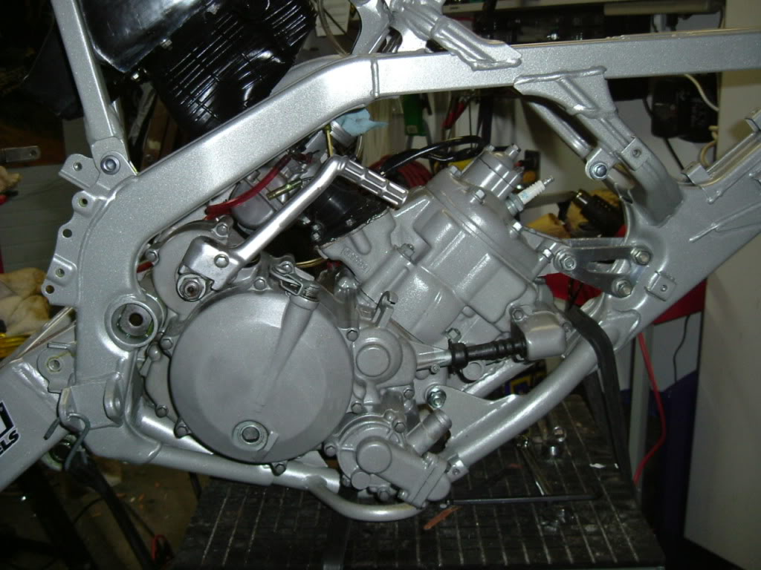

This is someone else’s bike. That sure looks like a KX125 lever. It seems to show that there is a lot more room on the KDX frame than on the CR frame.

